TASK ON ASG
1.Create one VPC in N. Virginia region.
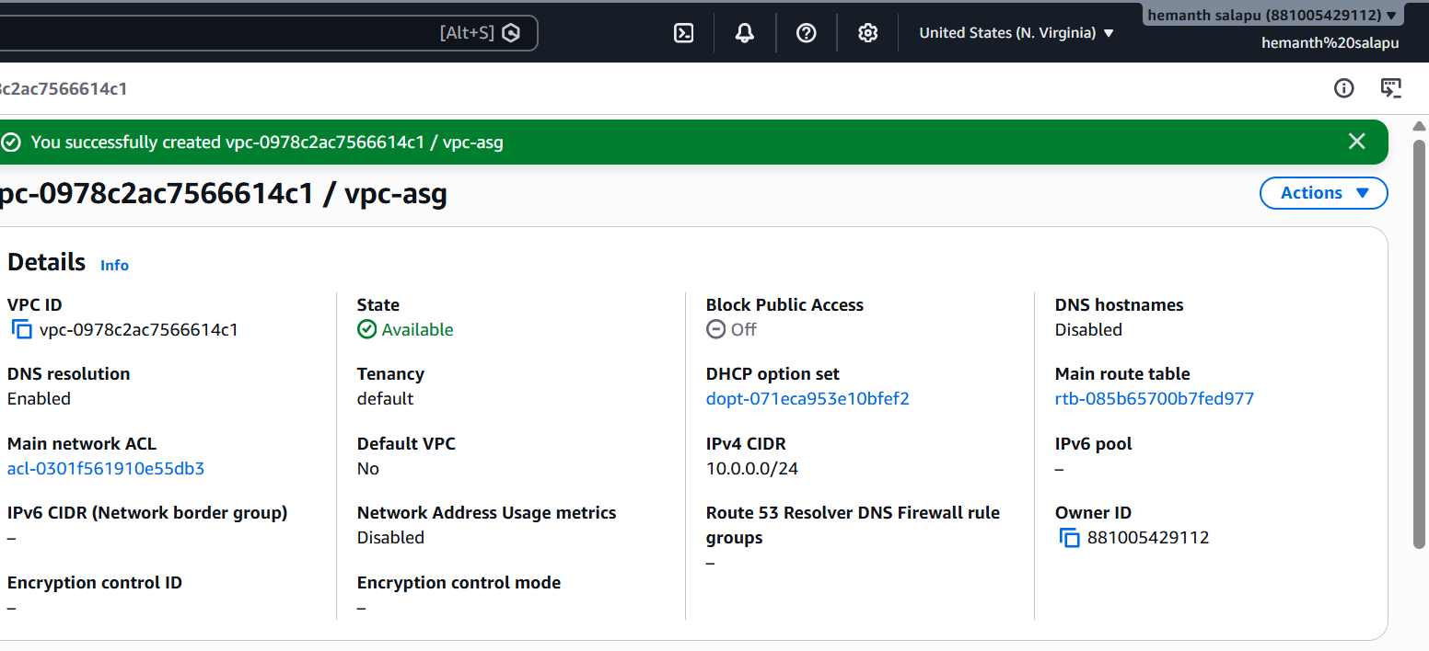
2.Create two subnets: one public subnet and one private subnet.
Public subnet created
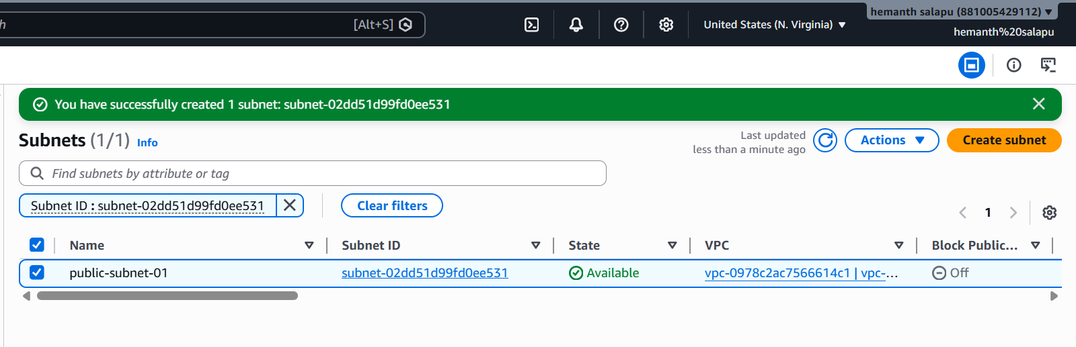
Private subnet created
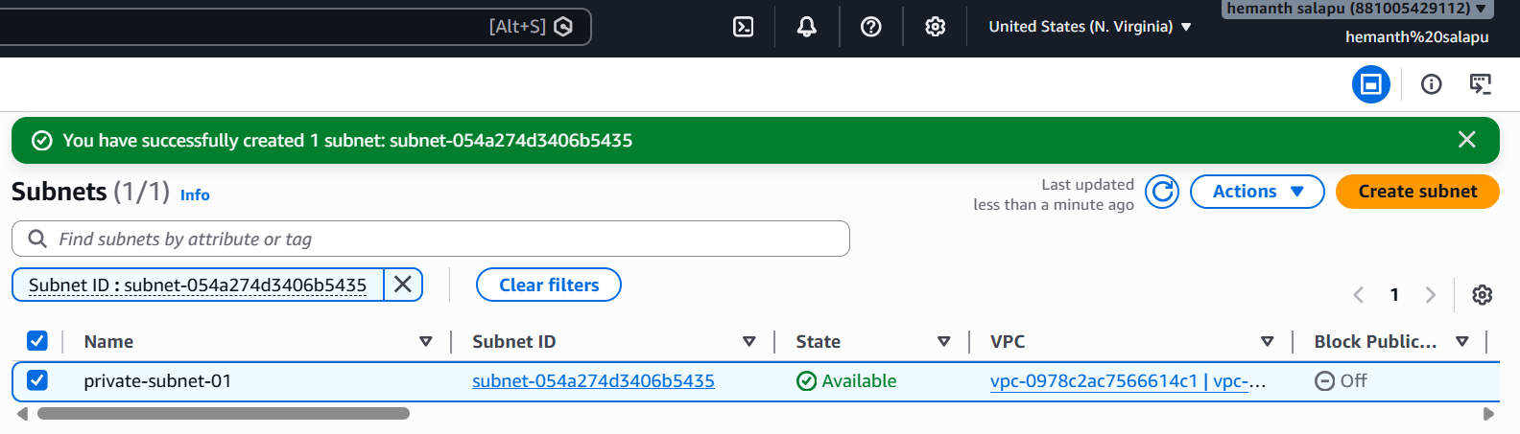

3.Attach an IGW to the VPC.
Internet gateway attached to vpc
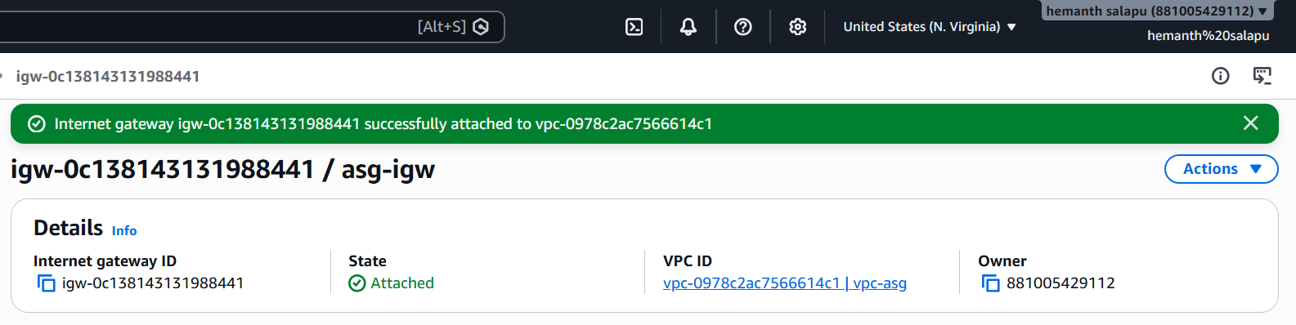
4.Create one public route table (RT) and one private route table.
Public route table created
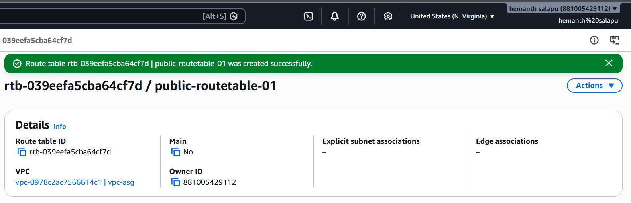
Private route table created
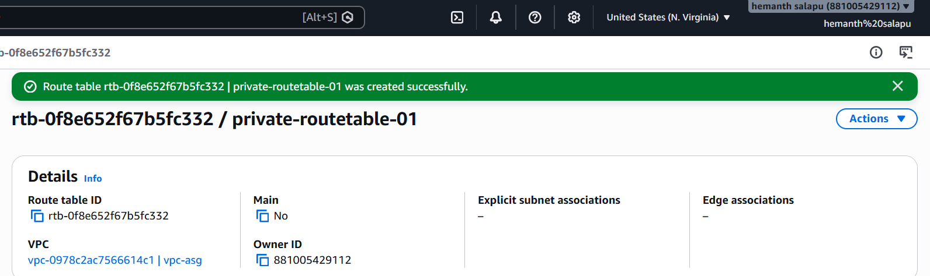
5.Deploy a NAT gateway in the public subnet and attach the NAT gateway to the private subnet.

NAT gateway deployed in public subnet
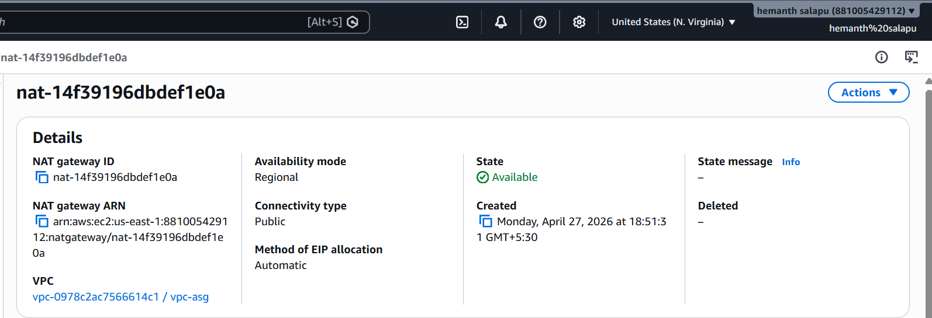

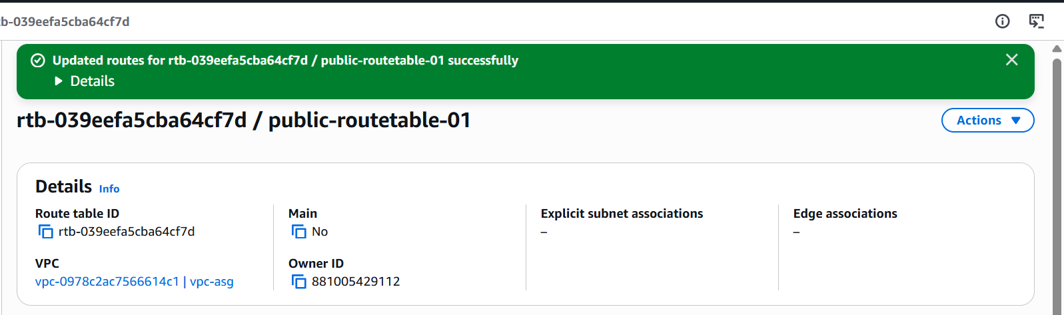

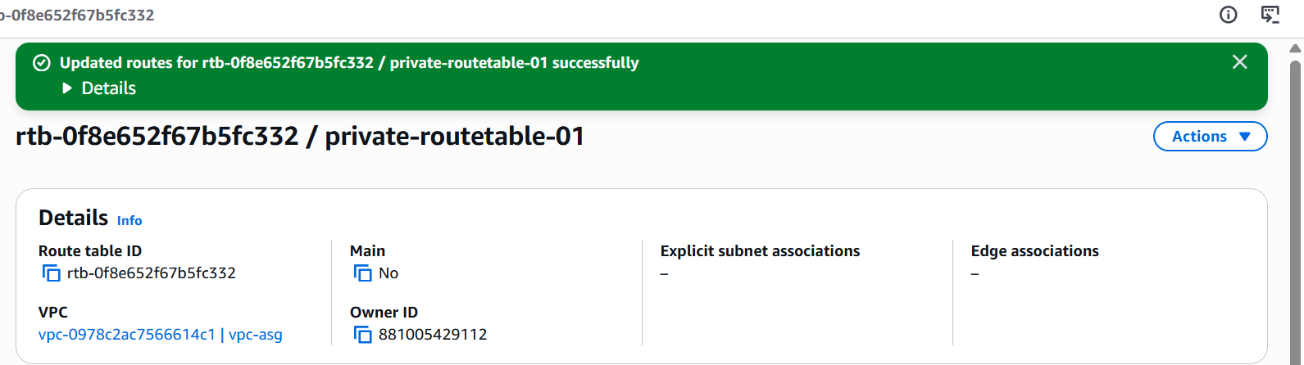
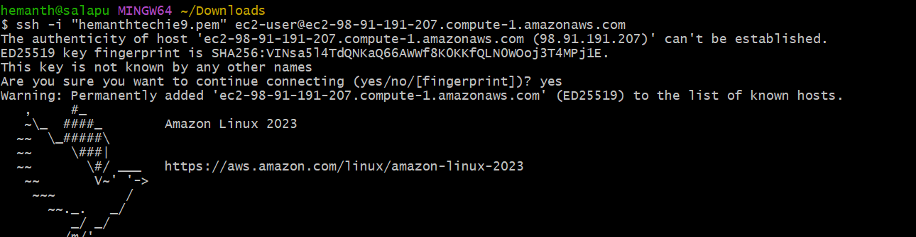

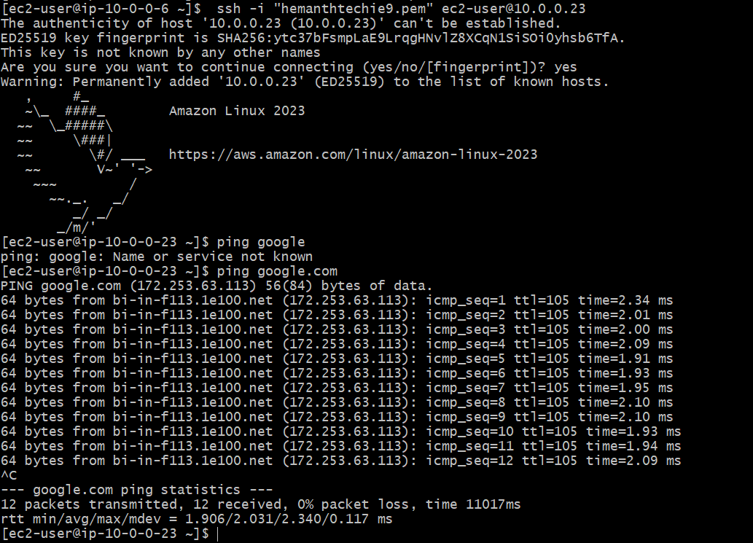
6.Create two instances, one in the public subnet and one in the private subnet.
Instance created in public subnet
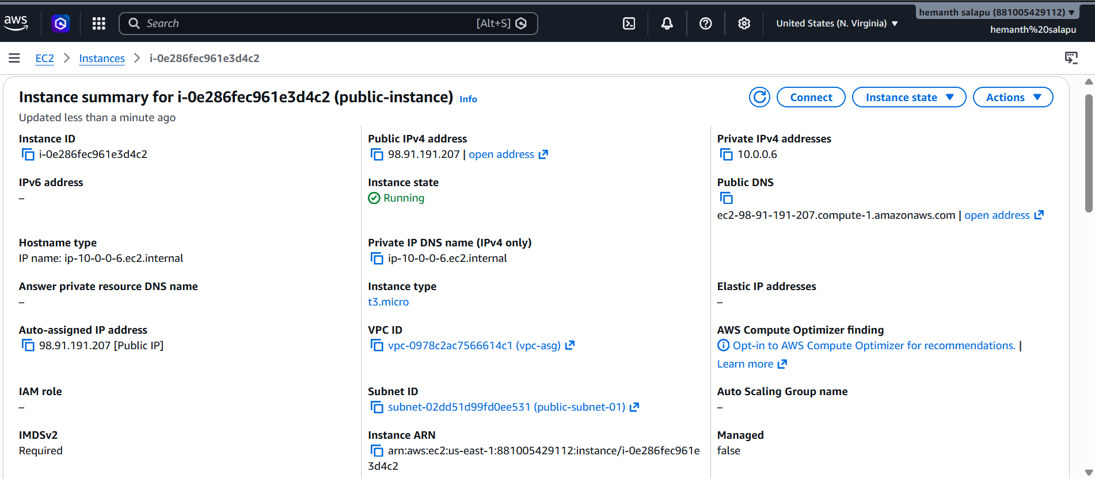
Instance created in private subnet
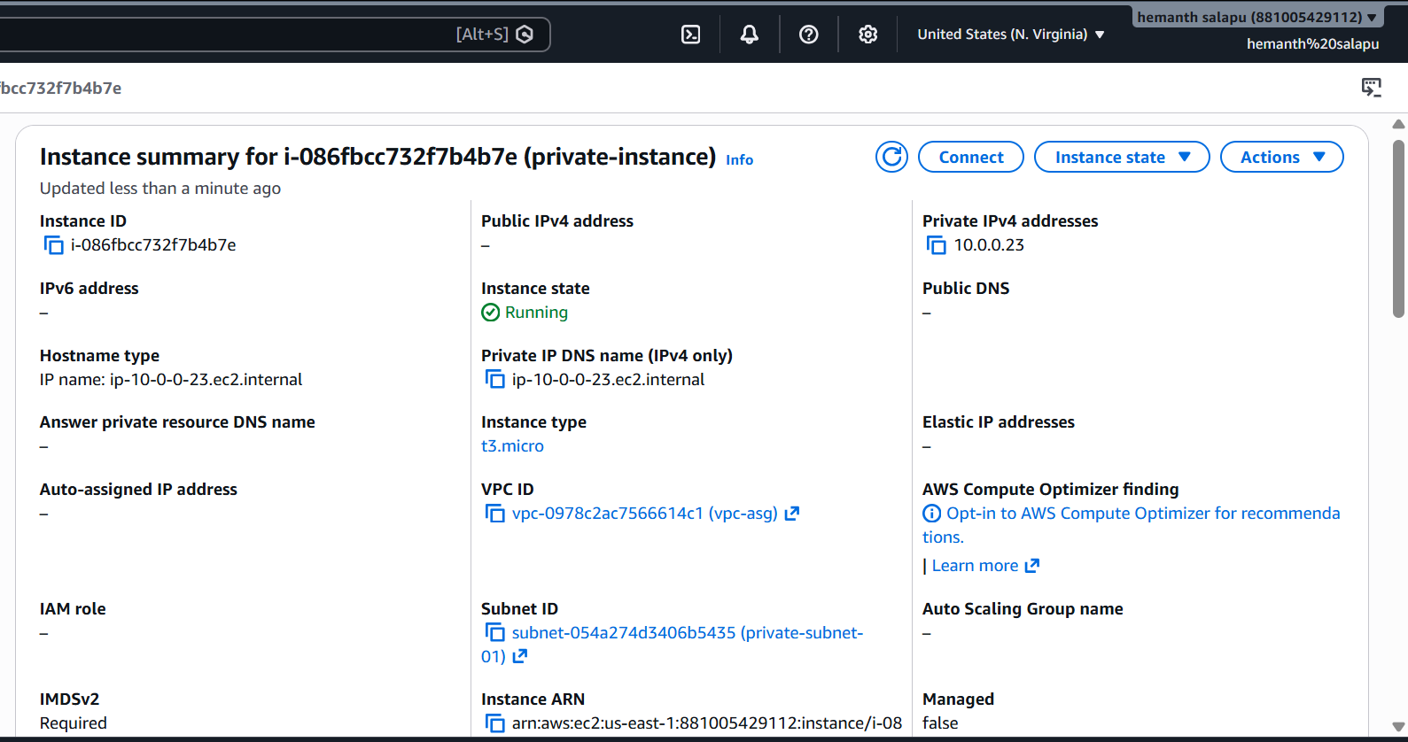
7.Deploy Apache server on both EC2 instances with a sample index.html file.

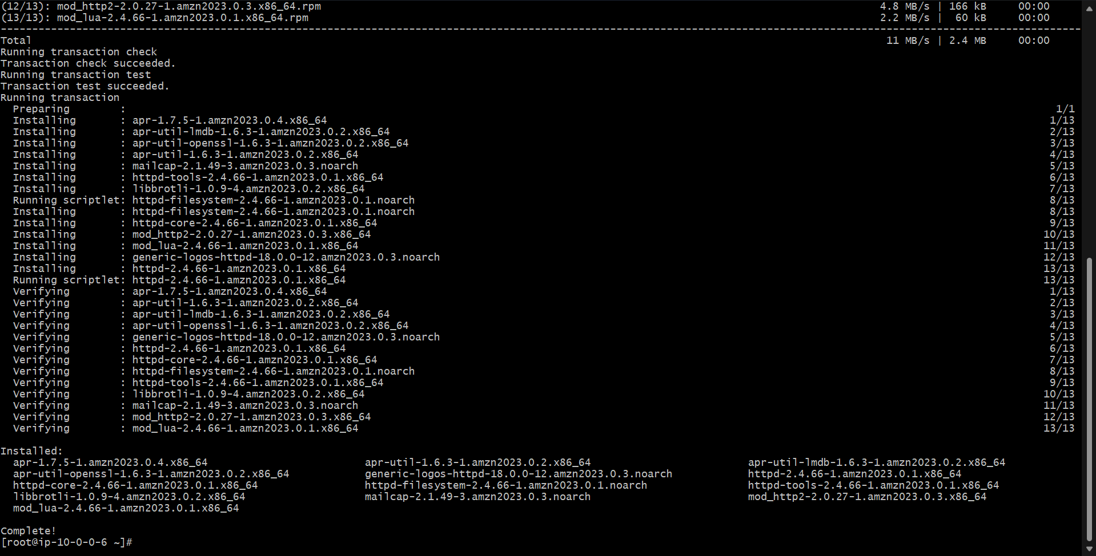
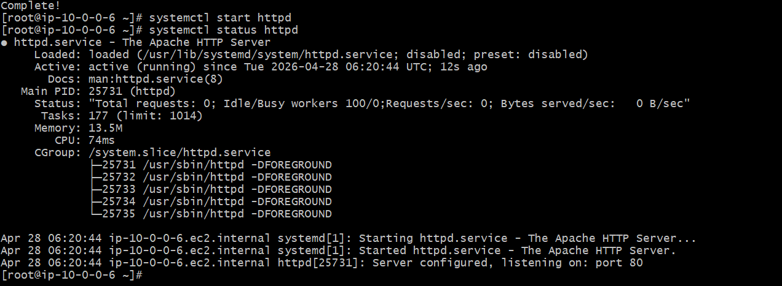
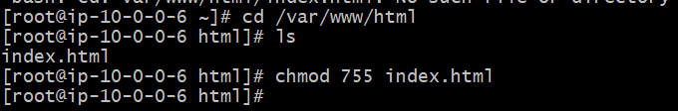
Its running successfully
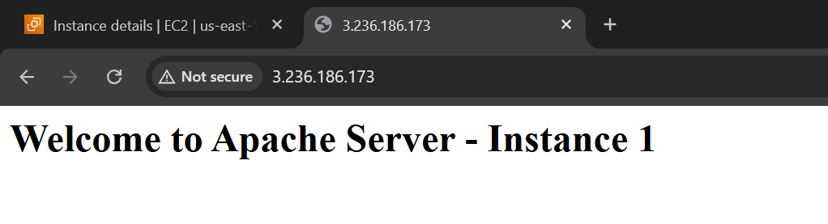
Connected to the private instance via public instance
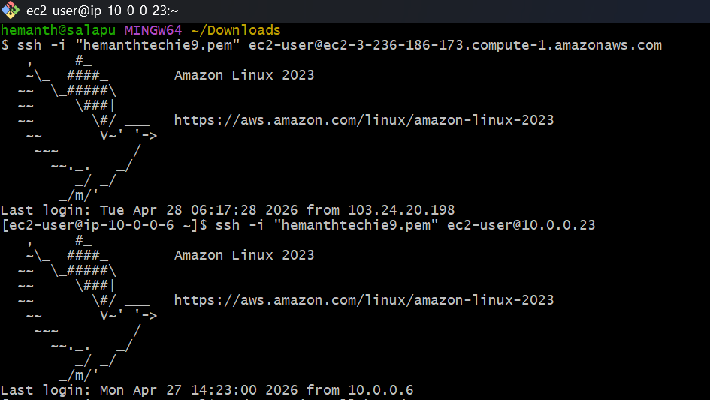
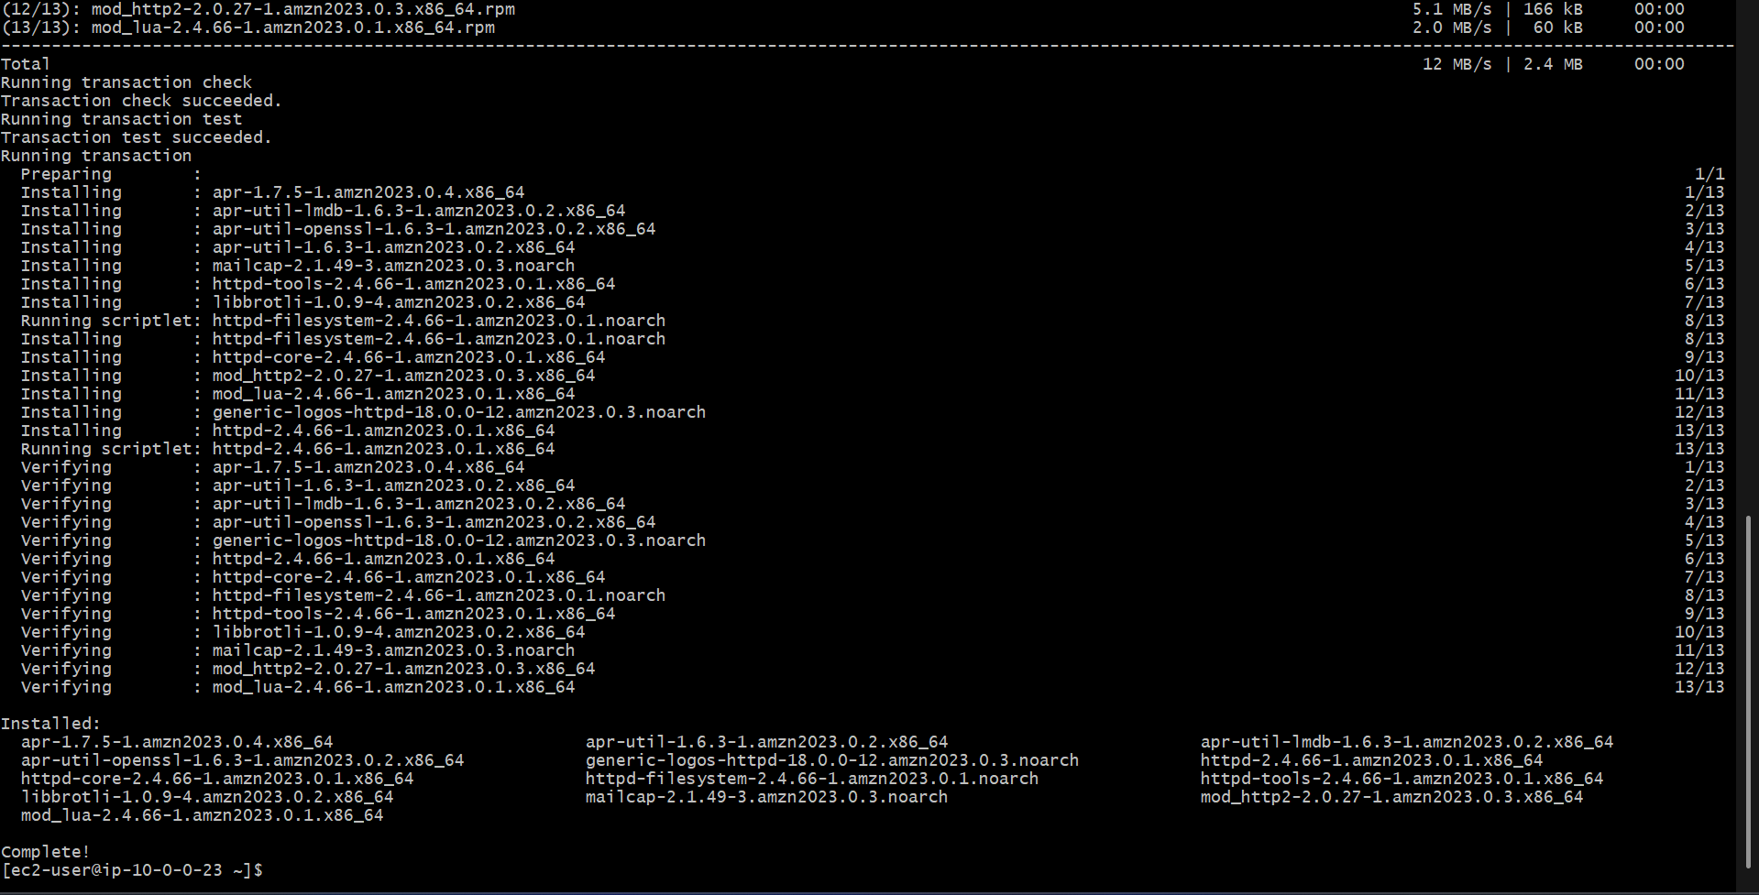
Installed http and running successfully
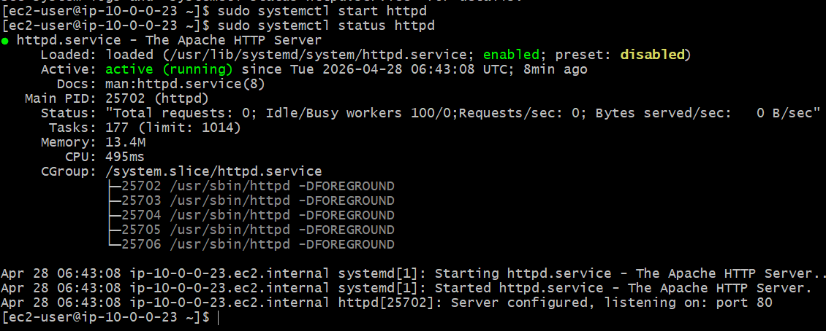

8.Create one application load balancer and attach it to both EC2 instances.
Created one load balancer
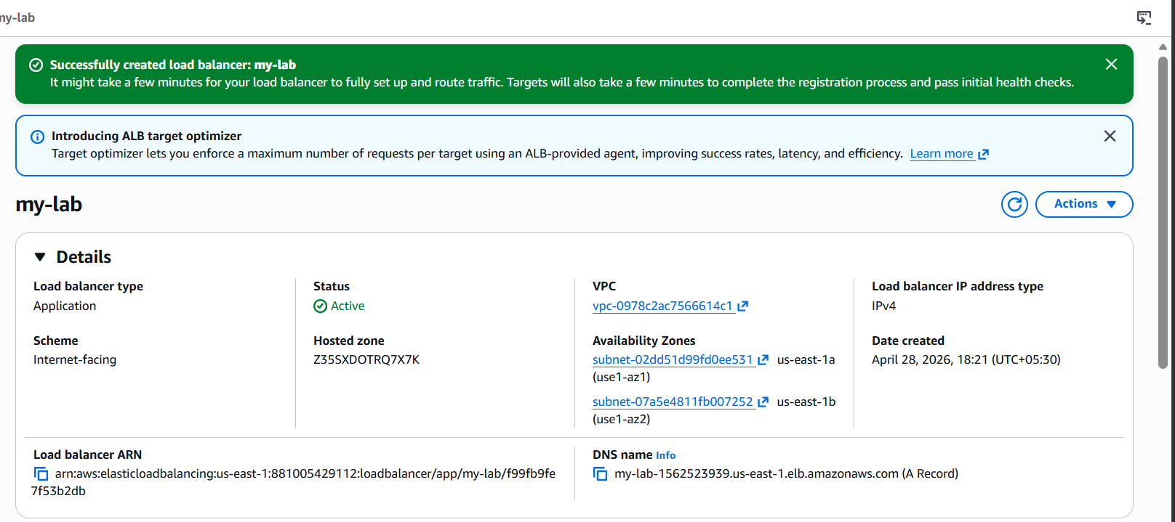
Created a new target group and configured with two instances and health check done
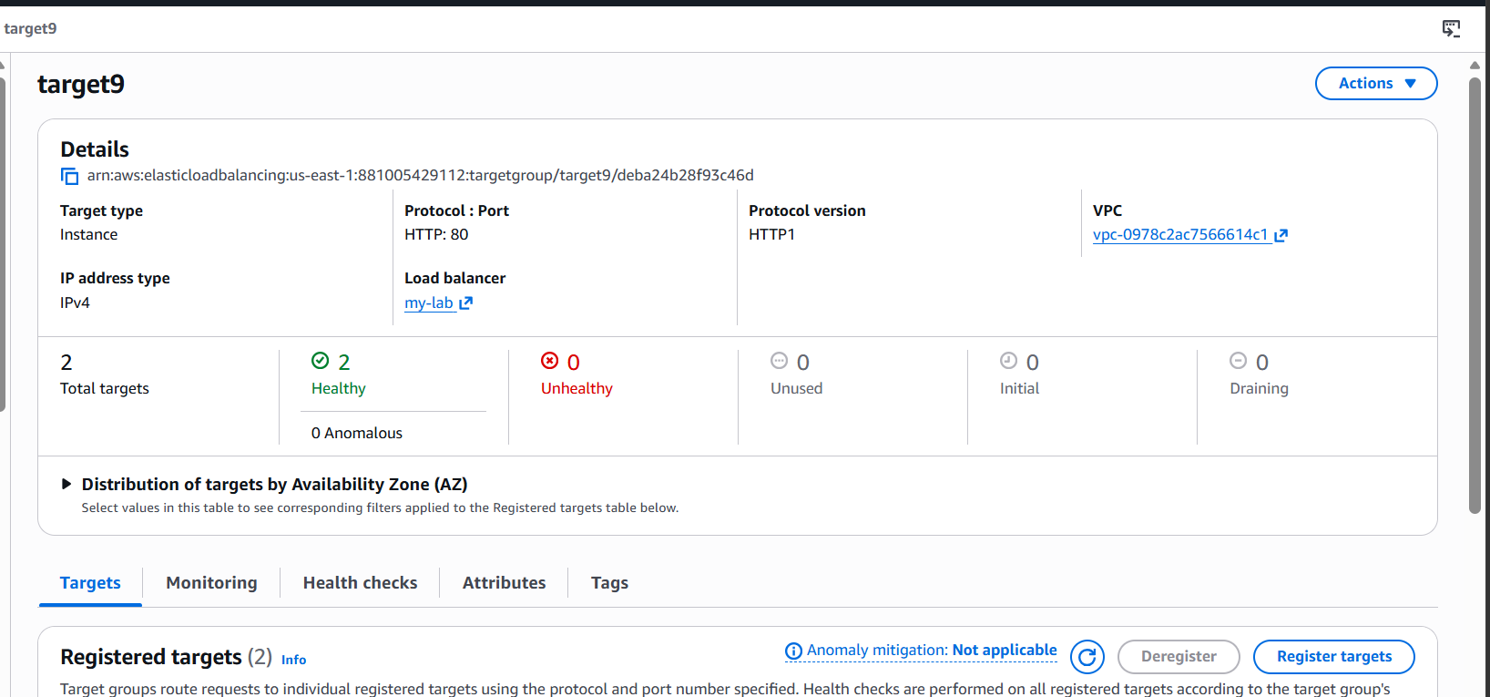
Checked with DNS name with load balancer in browser
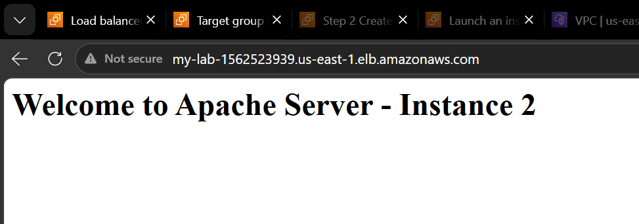

9. Store application load balancer logs in S3.
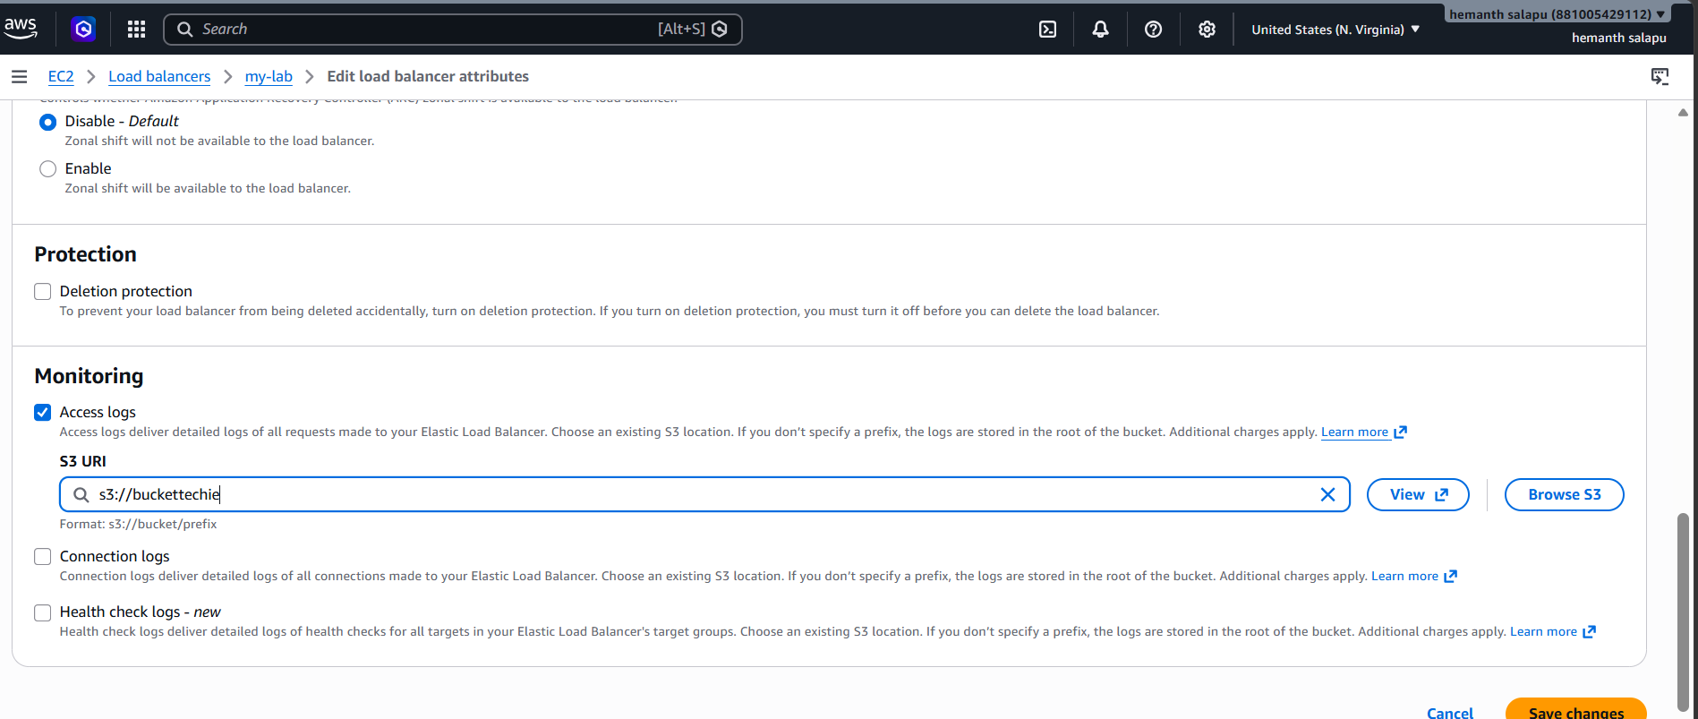
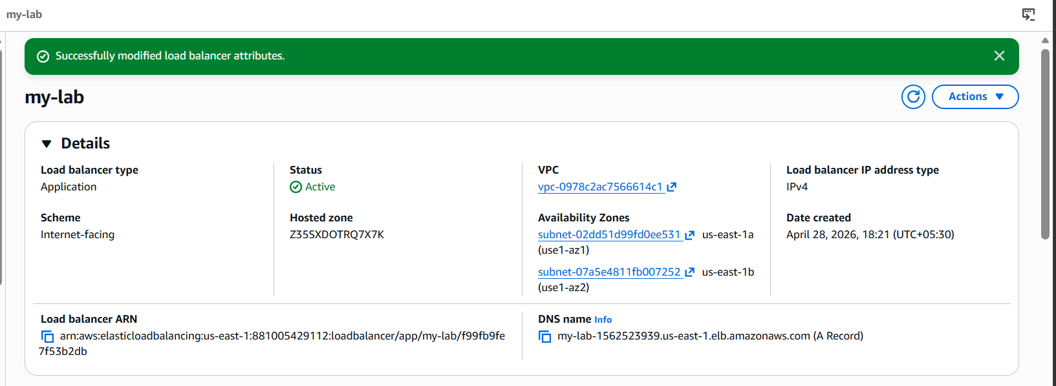
10. Store the VPC flow logs in a CloudWatch log group.
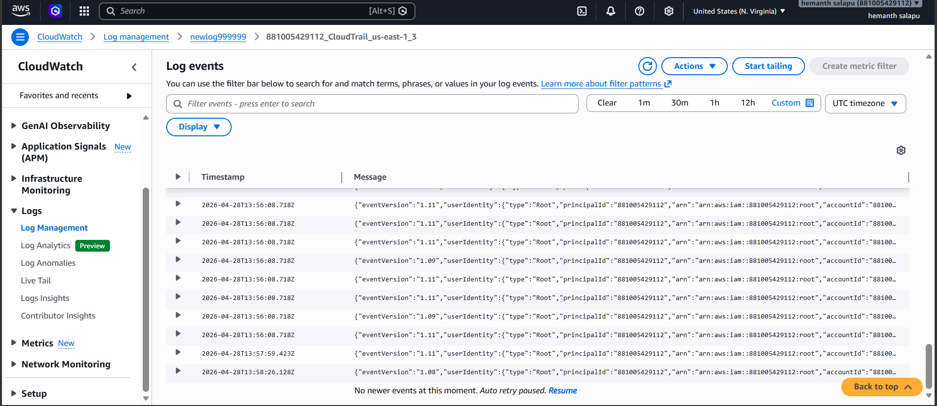
11. Create monitoring dashboards to monitor CPU utilization and to monitor the Apache service.
Installed cloud watch agent on public instance
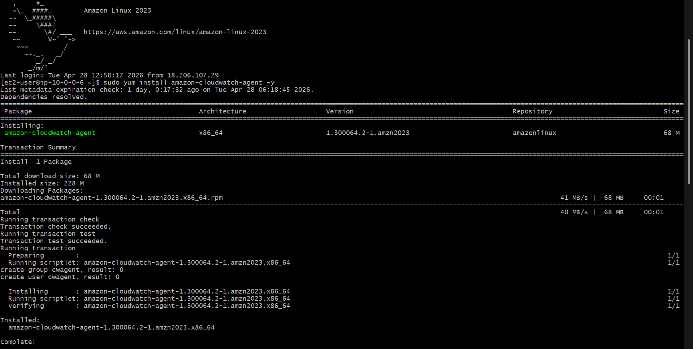
Installed cloud watch agent on private instance
Created new dashboard in cloud watch

12. If CPU utilization is more than 70%, then it should trigger auto scaling and launch new instance.
Created a launch template
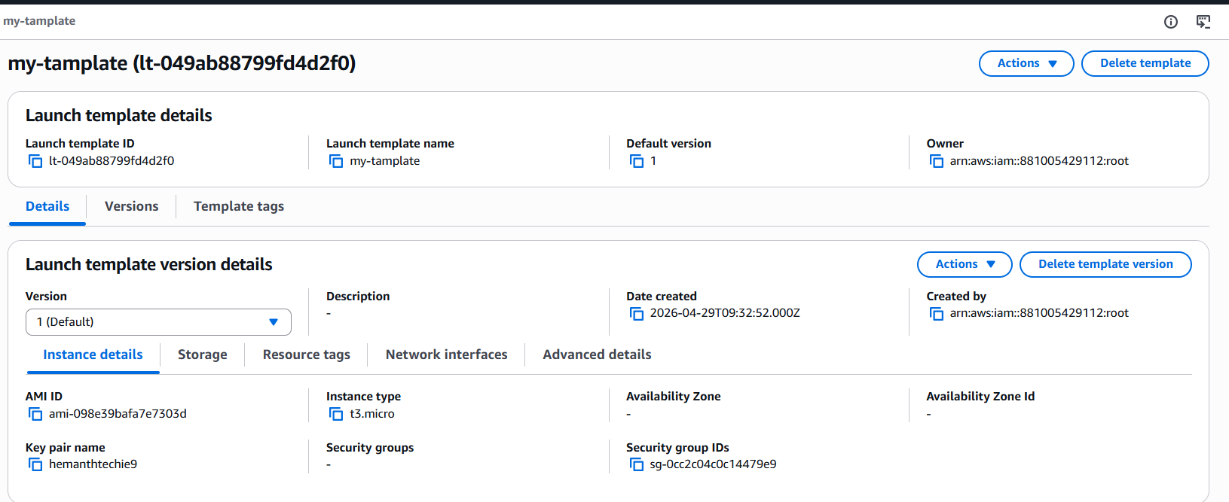
With that launch template we can create auto scaling group.
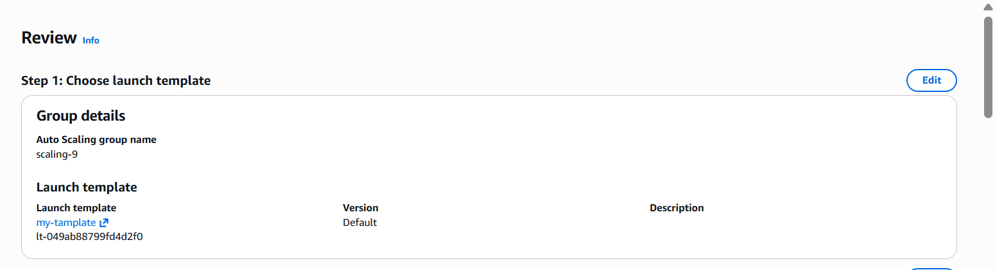
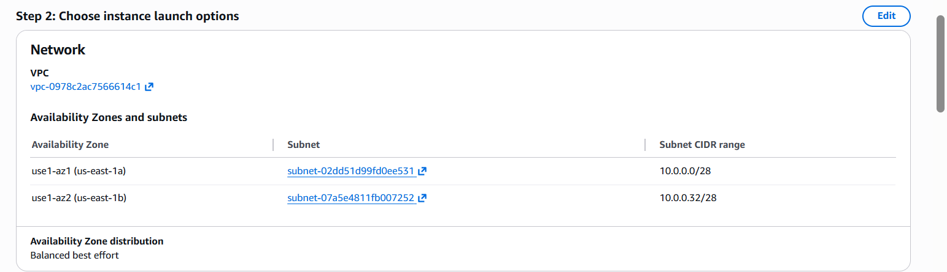

Created a auto scaling group
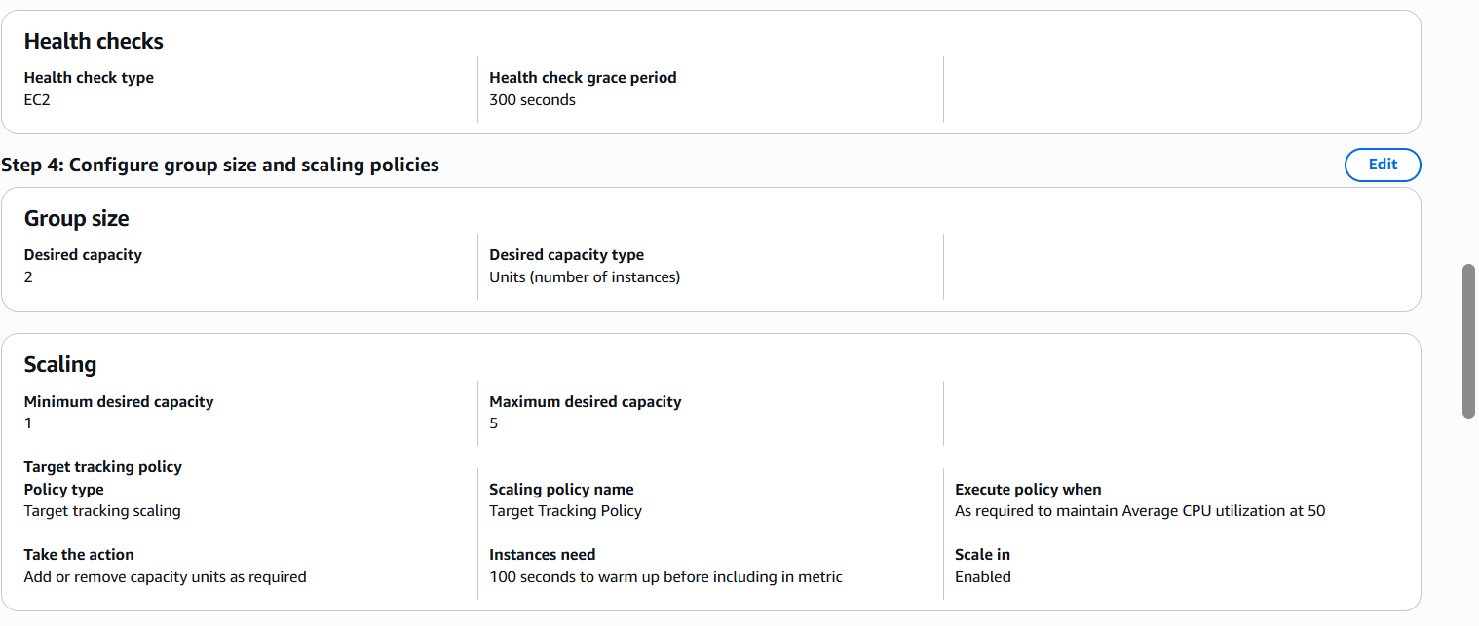
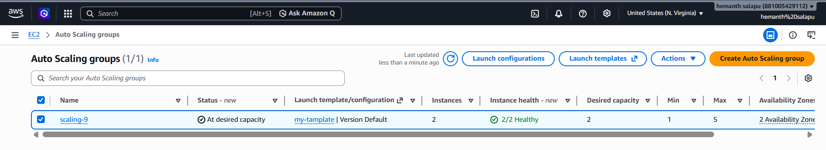
We can check activity tab, what instance created or terminated.
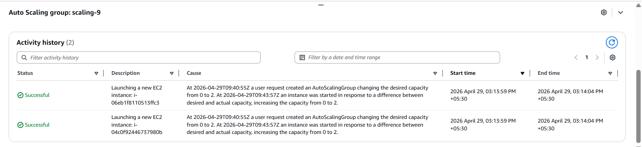
By default automatically created two instances..
